Chapter 2 Principles of Ecology Name:___________________________
Biology Date:____________________________

Study Guide

Know all vocab words and definitions

Ecology is the systemic stud of organisms and their interaction with the environment

Reveals the relationship between living and nonliving parts for the environment.

Examples of what is non-living that we need to live with

Multidisciplinary: geology, physics, chemistry, mathematics, other

Organisms can’t not exist in isolation, they depend on each other for survival, they also depends on nonliving things

Nonliving environment.

Abiotic factors: all the nonliving parts of the environments. Samples: tocks, sands, water, rainfall

Living enviro.

Biotic factors: all the living things that inhabit an environment

5 levels of organization:
Organism, population, communities, ecosystems, biosphere

Organism: living things
Population: group of organisms that live together and interbreed, living in the same place at the same time. Same species same place same time
How they share their resources determines how far apart they live and how big the population gets.
Communities: made up of several populations that interact; diff species same place same time
A change in population of a community will cause a change in another population.
Ecosystems: collection of interaction among the population in community and their abiotic factors. 1st adding in the environment
- Terrestrial- on land
- Freshwater
- Saltwater/marine
Biosphere: entire potion of either that supports life ; extends to the bottom of the ocean to high in the atmosphere.

Habitat: place where an organism lives out it’s life. Ex grassland, desert, the ocean floor
Niche: the role and position a species has in its environment and how it meets its needs for food and shelter how it survives, hoe it reproduces,
- It is n advantage for a species to occupy a different niche than another. (less completion)

Symbiosis (living relationships): Some species enhance their chances of survival by forming relation with other species. 3 types

Commensalism: a relationship in which one organism benefits and the other is neither harmed nor benefits (humming bird catching a ride with a bigger bird when flying south)
Mutualism: when both species benefit from the relationships (ex: bees and flowers)
Parasitism: when one organism benefit from harming the other organism (tapeworm)

Give examples of each relationship and tell you what it is.

2.2
Energy comes from where? Ultimately is the sun
Anything a living organism does requires energy.

Producers – are able to use energy from the sun to make food
Autotrophs
- Ex plants and some weird bacteria that we call chemosynthetic autotrophs
Consumers – need to eat in, order to get energy
Heterotrophs
- animals
types of heterotrophs
scavengers: rely on the efforts of others to find their foods ex vultures
herbivores: eat only plants ex cows/horse
carnivores: animals that eat other animals ex cats, tigers
Omnivores: animals that eat both plants and other animal’s ex bears, humans
Decomposers: break down and use nutrients from dead organism ex fungi

Food chains- are pathways of energy and matter through all organisms in an ecosystem

When one organism eats another, it receives the nutrients and energy from the organism it ate.

Food chain works with autotrophs then heterotrophs then decomposers
Every link in the chin only had about 10% of tis total energy available for the next link in the chain - as you go up in the chain you get less energy

Trophic levels are the feeding steps in the food chain
Only one possible route from the transfer of energy in an ecosystem

Food web- models that are used to describe all the possible feeding relationships amount animals
More realistic than food chains bc they show how animals rely on more than one type of food.

Ecological pyramids – is a model that used to show the distribution of matter and energy in ecological system
Autotrophs are on the bottom follow by heterotrophs

Cycles in nature
There is a law in science that says that matter can never be created nor destroyed – thus the atoms that make up the nutrients we need to live must be recycled
Water Cycle
Condensation: when h2o in the air condenses on an object cooler than the air
Evaporation: when water is turned into a vapor
Precipitation: rain, snow, and hail are good examples
Transpiration: when water passes through plants into the air as water vapor

Nitrogen cycle
Even thought the air contains 78% nitrogen, plants can not use nitrogen in that form
Lighting and certain bacteria converts nitrogen in the air into a more usable form for plants
Fertilizer is a useable form of nitrogen from plants

Carbon cycle
https://www.youtube.com/watch?v=c5KqwhX1dvk
Natural carob cycle- photosynthesis carbon
Respiration what the living things do to make carbon
Digestions – breaking the food into li

Carbon is the basis of organic molecules
Proteins, carbohydrates (glucose made by photosynitcs), lipids, nucleic acids

Plants and producers
- absorb co2 during photosynthesis
- produce glucose via photosynthesis
animals
glucose moves up the food chain
- co2 released into atmosphere
decomposer
- obtain glucose by feeding on the dead
- co2 release into atmosphere
human contribution
- excess co2 is being released from the burning of fossil fuels (coal, oil, natural gas
- cycle is out of balance
bc there is to much CO2 with deforestation and to heightened global warming and climate change
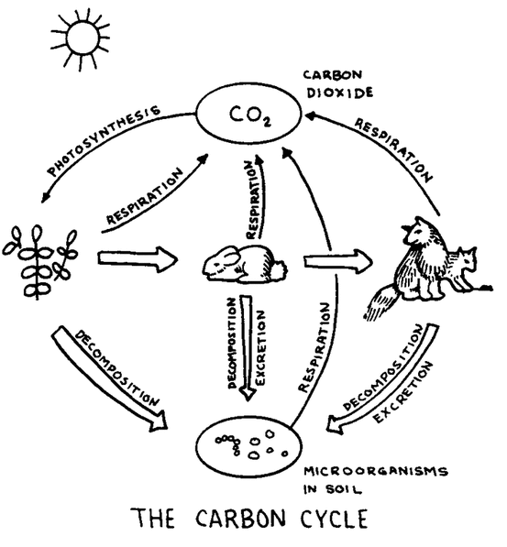

phosphorus cycle
https://www.youtube.com/watch?v=c5KqwhX1dvk
problem: no phosphorus in atmosphere
Needed to make up ATP, DNA, lipids (cell membranes)

- phosphorus released from the wreathing of rocks
- producers absorb phosphorus though their roots
- phosphorus moves up the food chain as animals eat producers
- decomposers obtain phosphorus as they feed on dead remains.
  - Phosphorus release in waste
Human contribution
Fertilizers (contain phosphorus) added to help grow crops
Problem:
- phosphorus runs off with rain
- Algal blooms – extreme growth of algae
- Eutrophication = dead zone due to lack of O2 and change the pH
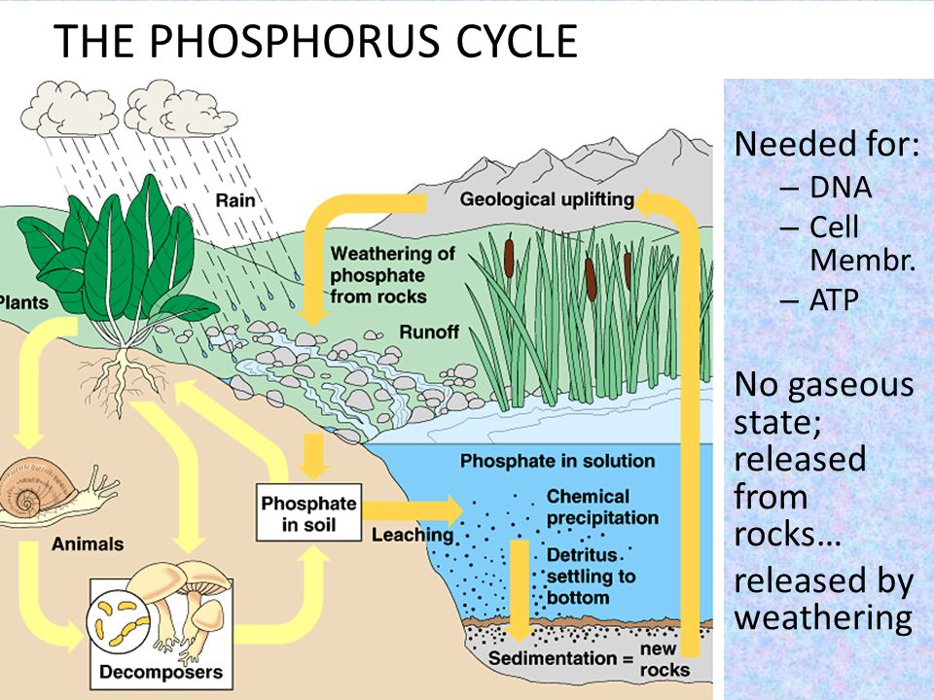

Name three imporatn organic molecules that are partially made from phosphorus.
How are humans disruption the phosphorus cycle?
What is eutrophication?

Chapter 3
Communities

Communities is made up of several populations that interact
A change in one population of a community will cause changes in another population.

Limiting factors- is any biotic or abiotic factor that restricts the existence, numbers, reproduction, on distribution of organisms
Predators, temperature, food availability and moisture are a few examples of limiting factors.
Ranger of Tolerance
- refers to an organisms ability to withstand fluctuations in biotic and abiotic environmental factors.
- Organisms deep in the sea have a higher tolerance of lack of sun and high amounts of pressure than other aquatic organisms.

Succession
- Is the orderly and natural changes that take place in communities of an ecosystem
- Occurs in stags:
  - Different species at different stages make conditions that are suitable for the following species.
  - Succession is often hard to observe because it takes years to happen

Tow types of succession
Primary:
- Occurs when a community is formed from building on rocks.
- Pioneer species are the first species to appear.
Secondary
- Occurs after a natural disaster or manmade structures are abandoned
- Soil is already present, so the pioneer stage is skipped

Primary seccession

Secondary succession

Pioneer species
- Lichen are combination of Two entirely different species that lie in a symbiotic realtions that demands the other for survival.
- Lichen are composed of fungus and algae.
  - Fungus receives food from the alga and the alga received moisture from the fungus
  - Lichen help cause rocks to weather fater and thus help start the production of soil.

Climax Community
- Is when a community has reached a level of stability and undergoes little or no changes.

